Beta Document

How too Install firmware to esp32 for Drybox

Install Arduino IDE V1.8 , NOT VERSION 2! <https://www.arduino.cc/en/software>

Once installed goto:-

File >

Preferences

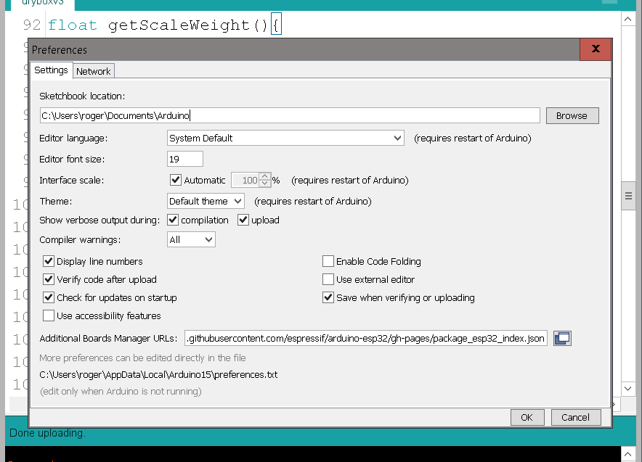

Add the line below into the “Additional Boards Manger URLs:”

<https://raw.githubusercontent.com/espressif/arduino-esp32/gh-pages/package_esp32_index.json>

Restart Arduino IDE

Once restarted goto:-

Tools  
 Board

ESP32 Arduino

*And select* ESP32 Dev Module

Next install Spifffs data upload add in

Instructions

<https://randomnerdtutorials.com/install-esp32-filesystem-uploader-arduino-ide/>

**** Close Arduino IDE*****

Copy the folder “AHTxx-main” into the “Sketch book location\Arduino\libraries” folder

Copy the folder “DryBox_valkyrie” into the ““Sketch book location\Arduino”

Double click the on the file “DryBox_valkyrie.ino” inside the “DryBox_valkyrie” folder

Arduino IDE should open. And look like this

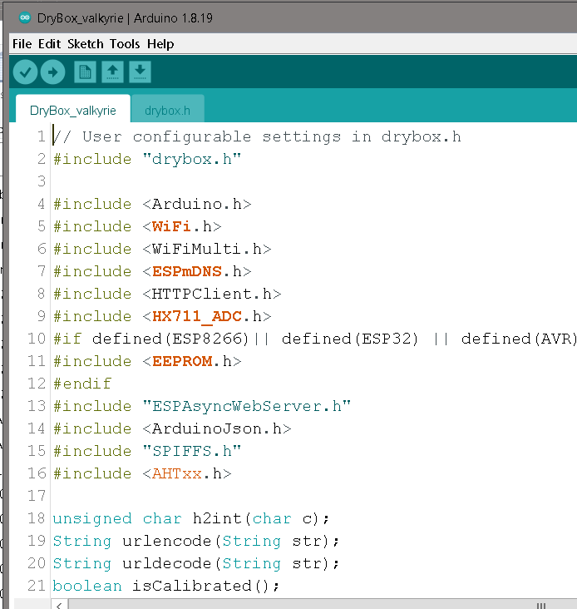

Click on the “drybox.h” tab and update the following

Your network SSID

And your network password

In Arduino IDE “File “ , “save”

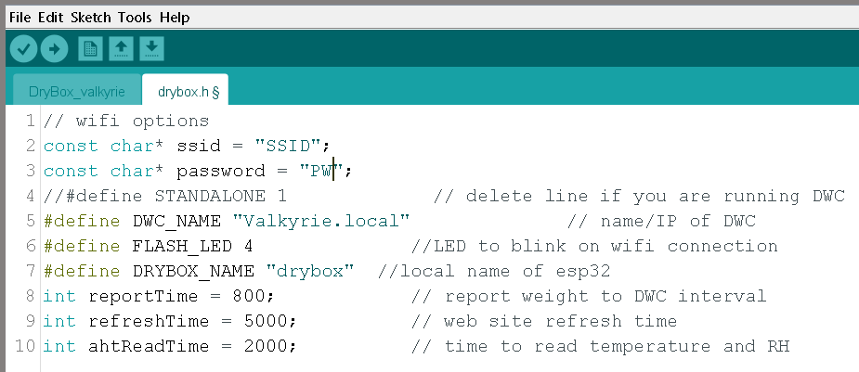

Now connect your ESP32 via USB to you PC,

In Arduino IDE “Tools” go down to “Port” and select the port number the ESP32 is connected to

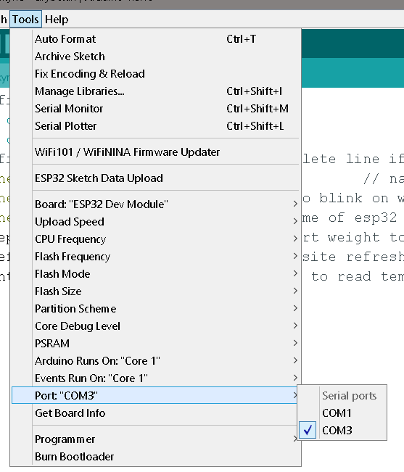

Next uploading Spiffs.

In Arduino IDE “Tools” go down to “”ESP32 Sketch Data Upload” and click, you will see files being uploaded , all being well should look like this.

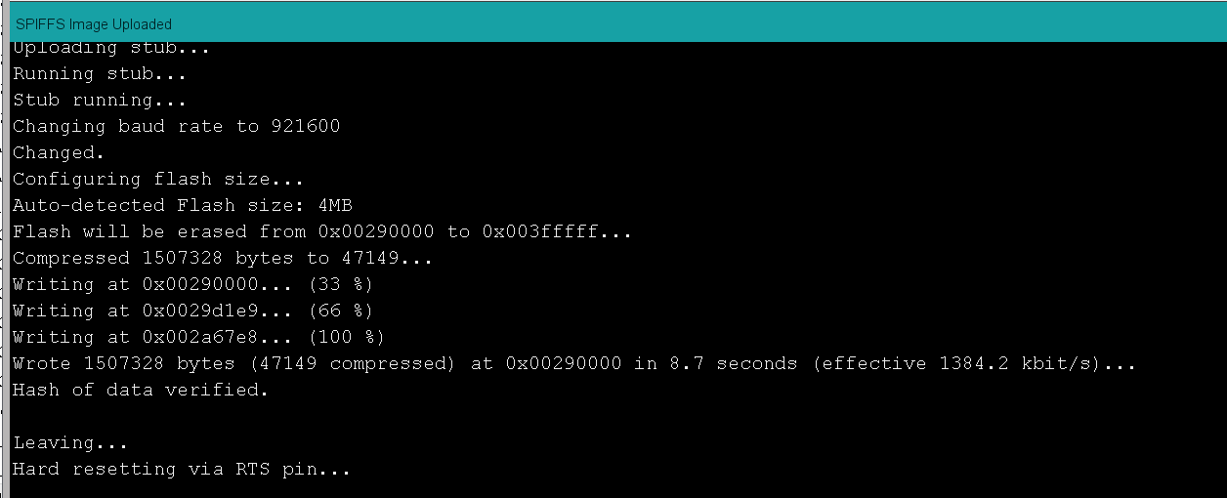

Next upload ino program file

Just click on the upload button.

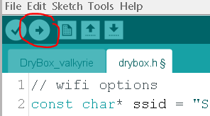

Files will then compile and upload to the esp32 this can take around 5 minutes, and should look like this when complete .

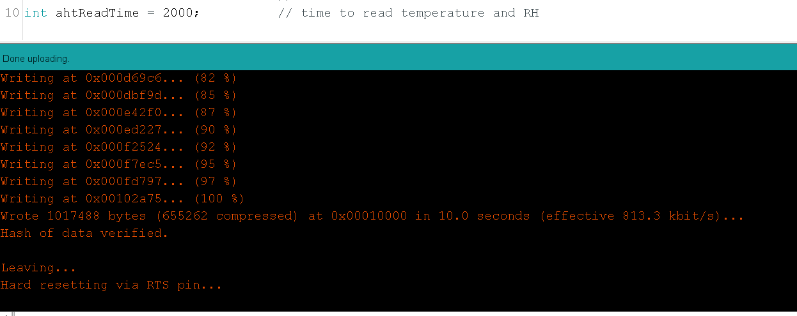

Now Edit config file in DWC

At the end of your config.g file add the following

;Global varibles Drybox

global preSpoolWeight = 0

global emptySpoolWeight = 0

global totalWeight= 0

global filamentWeight =0

global dryBoxTC = 0

global dryBoxRH = 0

global calWeight =0

global instructions = "No Message"

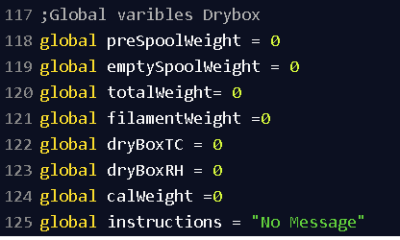

Save and restart Config file .

In DWC , go to “settings” , “plugins” and start “Object Model Browser”

Installing “BtnCmd” by MintyTrebor

https://github.com/MintyTrebor/BtnCmd/wiki

follow instruction “[Installing the Plugin](https://github.com/MintyTrebor/BtnCmd/wiki/Installation)”

Download the file “BtnCmdAutoRestore.json” from the DWC addin folder on Github to a local folder on your PC

Click on the “BtnCmd” button in DWC under control.

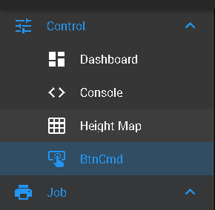

Click on the “show setting” wheel in BtnCMD



You should now see



Click on the icon that looks like a burger and click on the top icon “ import layers & Custom Panels

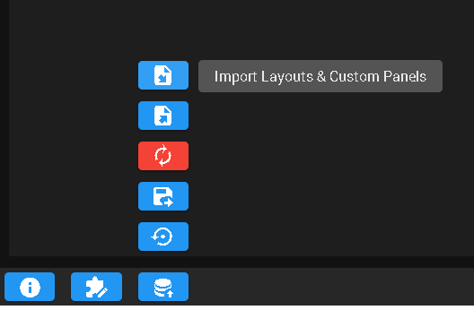

Select the file downloaded from git hub “BtnCmdAutoRestore.json”

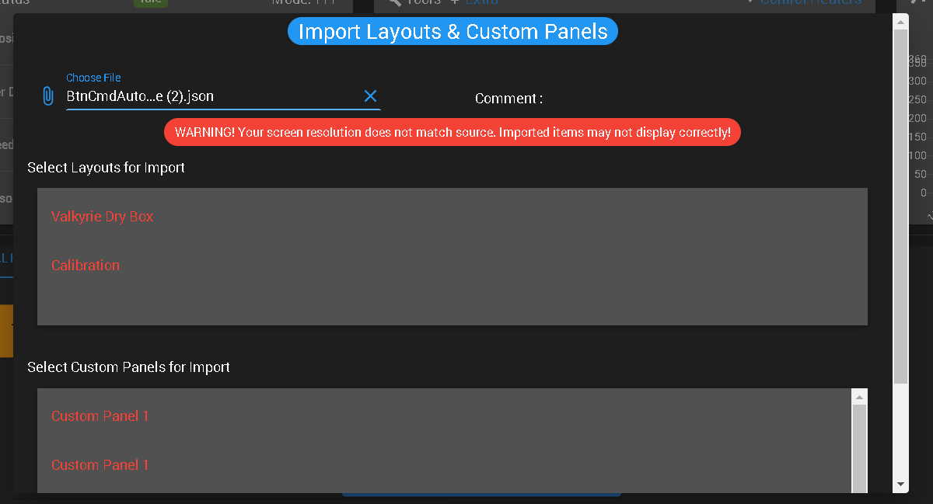

And then only select the “Valkyrie Dry Box and Calibration , then click “inport”

Your DWC should look like this

